Multi stage graph
A multistage graph is a directed graph where the nodes are divided into multiple stages, and edges only exist between nodes of consecutive stages. Each edge is assigned a weight representing the cost or distance associated with transitioning from one stage to the next.
Multistage graphs are commonly used to model optimization problems involving a sequence of decisions or stages, where the goal is to minimize or maximize some objective function while traversing the graph from the initial stage to the final stage.
In a multistage graph, the first stage typically represents the initial state or starting point of the problem, while the last stage represents the final state or goal. Intermediate stages represent intermediate states or decision points where choices must be made to progress towards the final goal. The edges in the graph represent transitions between stages, and the weights on these edges represent the costs or benefits associated with making those transitions

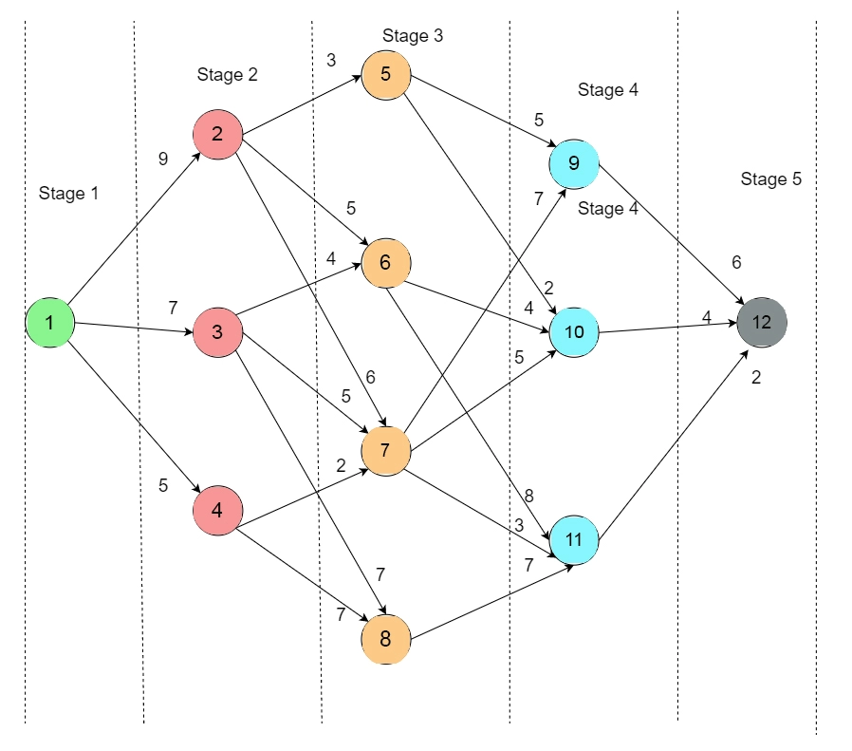
In the above graph, the cost of an edge is represented as c(i, j). We have to find the minimum cost path from vertex 1 to vertex 12. We will be using this below formula to find the shortest cost path from the source to the destination:
cost(i,j)=minimum{c(j,l)+cost(i+1,l)}

Step 1
In Step 1, we use the forward approach (cost(5,12) = 0).
Here, 5 is the stage number and 12 is a node. Since there are no edges outgoing from vertex 12, the cost is 0.

Step 2
Now, cost(4,9) = cost(9,12)= 6
cost(4,10) = cost(10,12)= 4
cost(4,11) = cost(11,12)= 2

Step 3
cost(3,5) = minimum{cost(5,9)+cost(4,9),c(5,10)+cost(4,10)}
minimum{5+6,2+4}
minimum{11,6} = 6
cost(3,5) = 6
cost(3,6)=minimum{cost(6,10)+cost(4,10),cost(6,11)+cost(4,11)}
minimum{4+4,8+2}
minimum{8,10}=8
cost(3,6)=8
cost(3,7)=minimum{cost(7,9)+cost(4,9),cost(7,10)+cost(4,10),cost(7,11)+cost(4,11)} minimum{7+6,5+4,3+2}
minimum{13,9,5}=5
cost(3,7)=5
cost(3,8)=cost(8,11)+cost(4,11)=7+2=9 cost(3,8)=9

Step 4
cost(2,2)=minimum{cost(2,5)+cost(3,5),cost(2,6)+cost(3,6),cost(2,7)+cost(3,7)} minimum{3+6,5+8,6+5}
minimum{9,13,11}=9
cost(2,2) = 9
cost(2,3)=minimum{c(3,6)+cost(3,6),cost(3,7)+cost(3,7),cost(3,8)+cost(3,8)} minimum{4+8,5+5,7+9}
minimum{12,10,16}=10
cost(2,3)=10
cost(2,4)=minimum{cost(4,7)+cost(3,7),cost(4,8)+cost(3,8)}
minimum{2+5,7+9}
minimum{7,16}=7
cost(2,4)=7

Step 5
cost(1,1)=minimum{cost(1,2)+cost(2,2),cost(1,3)+cost(2,3),cost(1,4)+cost(2,4)} minimum{9+9,7+10,5+7}
minimum {18,17,12}=12
cost(1,1)=12

Time Complexity
The time complexity of the algorithm used is O(V²). Here, V is the number of vertices. As we are using adjacency matrix representation. This time complexity of the approach is O(V²)

Space Complexity
The space complexity of the algorithm used is O(V). The adjacency list and min heap required O(V) spaces. That is why the space complexity of the approach is O(V).

